**3.2**

**a)** George Lucas directed Star Wars and Indiana Jones

Answer:

P: (*George Lucas*) directed Star Wars

Q: (*George Lucas*) directed Indiana Jones

**R: P ∧ Q** or you can just write**: P ∧ Q (voorbeeld van Andrej)**

**b)** George Lucas directed Star Wars but didn’t direct Game of Thrones.

Answer:

P: (*George Lucas*) directed Star Wars

~Q: (*George Lucas*) directed Game of Thrones

**R: P ∧ ~Q** (~=not, ik wist niet hoe je de andere teken kan doen en ik zag deze op via yt-link)

**c)**  If you are wrong, it is because you don’t think logically.

P: You are wrong

Q: Think logically

**R: P🡪~Q**

**d)** If we are living in a material world, then I am a material girl.

P: we are living in a material world

Q: I am a material girl

**R: P🡪Q**

**e)** If I am not a material girl, then I am a free spirit.

P: I am a material girl

Q: I am a free spirit

**R: ~P🡪Q**

**f)** Either a valid argument is sound or unsound, but no valid argument is cogent.

P: a valid argument is sound

Q: unsound

R:

**P🡪Q**

**g)** You learned Analysis 1 if and only if you didn’t fail the exam and know how to program.

P:You learned Analysis 1

Q: you didn’t fail the exam and know how to program

R: Know how to program

**P🡨🡪Q ∧ R**

**h)** If you are a team leader of your project team, then if your team member plagiarized one of the deliverables, then if you don’t report it to the teachers, then you will be suspended.

P: you are a team leader of your project team

Q: your team member plagiarized one of the deliverables

R: report it to the teachers

S: you will be suspended

**((P🡪Q)🡪~R)🡪S**

**I)** If you are a team leader of your project team and if your team member plagiarized one of the deliverables, then if you don’t report it to the teachers, then you will be suspended.

P: you are a team leader of your project team

Q: your team member plagiarized one of the deliverables

R: report it to the teachers

S: you will be suspended

**((P∧🡪)Q🡪~R)🡪S**

**3.3**

**a)** ¬P ∧ Q ∧ R **b)** (Q ∧ ¬P) → R

|  |  |  |  |
| --- | --- | --- | --- |
| **p** | **q** | **r** | (¬P ∧ Q ∧ R) |
| **F** | **F** | **F** | **F** |
| **F** | **F** | **T** | **F** |
| **F** | **T** | **F** | **F** |
| **F** | **T** | **T** | **T** |
| **T** | **F** | **F** | **F** |
| **T** | **F** | **T** | **F** |
| **T** | **T** | **F** | **F** |
| **T** | **T** | **T** | **F** |

|  |  |  |  |
| --- | --- | --- | --- |
| **p** | **q** | **r** | ((Q ∧ ¬P) → R) |
| **F** | **F** | **F** | **T** |
| **F** | **F** | **T** | **T** |
| **F** | **T** | **F** | **F** |
| **F** | **T** | **T** | **T** |
| **T** | **F** | **F** | **T** |
| **T** | **F** | **T** | **T** |
| **T** | **T** | **F** | **T** |
| **T** | **T** | **T** | **T** |

**c)** ¬R → (Q ∧ ¬P)

|  |  |  |  |
| --- | --- | --- | --- |
| **p** | **q** | **r** | ( ¬R → (Q ∧ ¬P)) |
| **F** | **F** | **F** | **F** |
| **F** | **F** | **T** | **T** |
| **F** | **T** | **F** | **T** |
| **F** | **T** | **T** | **T** |
| **T** | **F** | **F** | **F** |
| **T** | **F** | **T** | **T** |
| **T** | **T** | **F** | **F** |
| **T** | **T** | **T** | **T** |

**4.6**

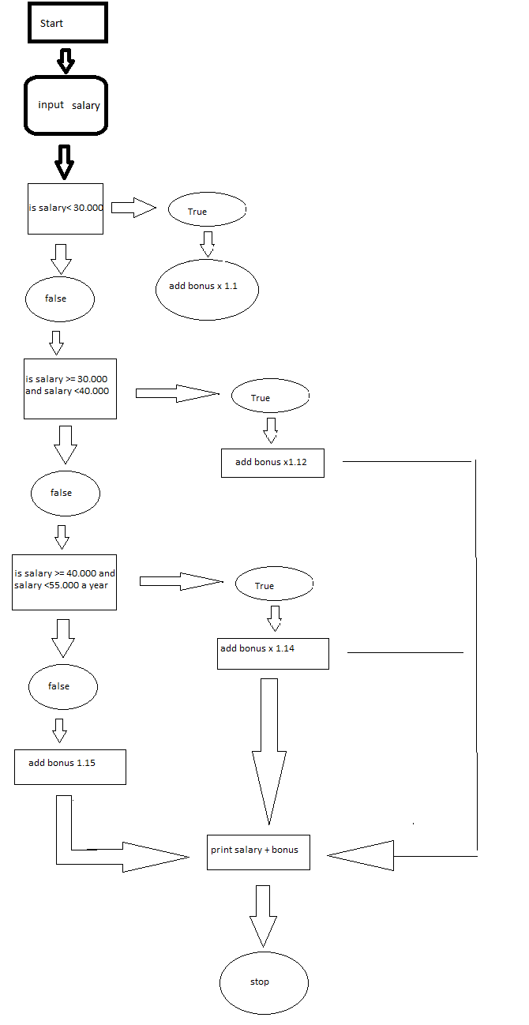

(Sorry voor kwaliteit, paint is slecht ☹)

**De code van python hiervoor is**salary = int(input('Please enter salary '))

if salary < 30000:

newSalary = 1.1 * salary

elif salary < 40000:

newSalary = 1.12 * salary

elif salary < 55000:

newSalary = 1.14 * salary

else:

newSalary = 1.15 * salary

print(newSalary)